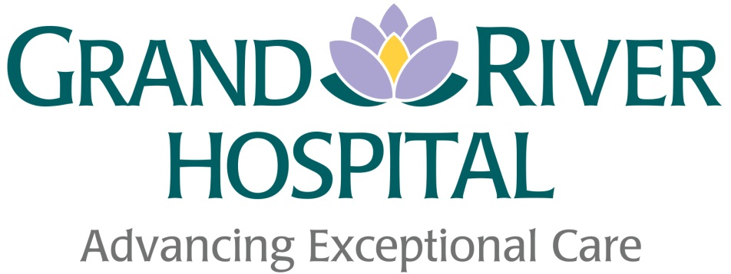

Annual Status Report On ACCessibility 2016

Prepared by:
GRAND RIVER HOSPITAL ACCESSIBILITY Committee

Prepared for:
Malcolm Maxwell, President and CEO

This publication is available on the hospital’s website at:
http://www.grhosp.on.ca/
and in alternative formats upon request.

Table of Contents

1. Executive Summary 3
2. Description of Hospital 5
3. Definitions 7
4. Grand River Hospital Accessibility Working Group 9
5. Hospital Commitment To Accessibility Planning 10
6. Accessibility Achievements - 2016 11

Executive Summary
Grand River Hospital (GRH) is committed to treating all people in a way that allows them to maintain their dignity and independence. We believe in integration and equal opportunity. We are committed to meeting the needs of people with disabilities in a timely manner, and will do so by preventing and removing barriers to accessibility and meeting accessibility requirements under the Accessibility for Ontarians with Disabilities Act (AODA) not because it is law but because it is the right thing to do.

Grand River Hospital is also committed to the continuous improvement of access to hospital facilities, policies, programs, practices and services for patients and their family members, staff, health care practitioners, volunteers and members of the community with disabilities.

The positive impact that this commitment has had on those with disabilities is evident through the feedback we receive. The following is a quote from a grateful patient.

“I have visited an outpatient clinic here at Freeport a couple of times now and I am so happy with the new accessible washrooms just down the hall from the main entrance. The washrooms are so big and spacious so using my wheelchair is easier than ever. I also like the color indicator on the wall outside the washroom doors that tells me which washroom is vacant. Very helpful - great work Grand River Hospital! ”

James

We will continue to build on our recent successes to improve access.

The Integrated Accessibility Standards Regulation (IASR) 2011 of the Accessibility for Ontarians with Disabilities Act (AODA) 2005 requires all public sector organizations to develop a multi-year accessibility plan outlining strategies to identify, remove and prevent barriers for persons with disabilities. At Grand River Hospital this was achieved in December 2013 when the 2014-2018 Multi-year Accessibility Plan was published and posted on our external website.

The legislation also requires all organizations to prepare and post an annual status report regarding the year’s progress towards goals and targets identified in the multi-year accessibility plan. This Annual Status Report on Accessibility 2016 documents the planning and implementation activities undertaken by Grand River Hospital in 2016 in order to demonstrate both compliance with legislation as well as our firm and ongoing commitment to creating and expanding the accessibility of services and processes for patients, visitors, families, employees, physicians and volunteers.

Description of Hospital
Grand River Hospital (GRH) is Waterloo Wellington’s largest hospital. The work of the hospital is guided by its mission, vision and values statements.

Mission: At Grand River Hospital, we work with the communities we serve towards life-long health and well-being for all. We exist to provide exceptional care through inspired people, one patient at a time.

Vision: We’re your hospital, bringing you exceptional care for your health, today, and tomorrow

Values: Compassion, Collaboration, Positive Attitude, Professionalism, Respect

We strive to provide exceptional services that comfort, assess, restore and educate patients through 15 clinical programs and services in a fiscally-responsible manner. GRH delivers these services within the context of the broader health system acknowledging that the needs of patients extend beyond the services provided by GRH. Through effective partnerships and linkages with other health service providers in the Waterloo Wellington area and beyond, GRH will participate in the coordination and integration of services that best serve the population of Waterloo Wellington.

In 2017/18, GRH will operate a 574-bed large community hospital delivering a full range of acute care, rehabilitation and complex continuing care services on two main campuses, the Kitchener-Waterloo campus (including 835 King Street, 850 King Street, 403 Park Street, and 52 Glasgow Street), the Freeport campus and five satellite locations in Kitchener, Guelph, Palmerston, Fergus and Mount Forest.
Grand River Hospital (GRH) provides 15 clinical programs and services including:
- Cancer Care | - Medicine
- Childbirth | - Mental Health & Addictions
- Children's | - Pharmacy
- Complex Continuing Care | - Rehabilitation
- Critical Care | - Renal
- Emergency | - Stroke
- Laboratory Medicine | - Surgery
- Medical Imaging

Definitions
Within this document, the term:
“barrier” means:
Anything that prevents a person with a disability from fully participating in all aspects of society because of his or her disability including a physical barrier, an architectural barrier, an information or communication barrier, an attitudinal barrier, a technological barrier, a policy or a practice.

“disability” means:
- Any degree of physical disability, infirmity, malformation or disfigurement that is caused by bodily injury, birth defect or illness and, without limiting the generality of the foregoing, includes diabetes mellitus, epilepsy, a brain injury, any degree of paralysis, amputation, lack of physical coordination, blindness or visual impediment, deafness or hearing impediment, muteness or speech impairment, or physical reliance on a guide dog or other animal or on a wheelchair or other remedial appliance or device;
- A condition of mental impairment or a developmental disability;
- A learning disability or a dysfunction in one or more of the processes involved in understanding or using symbols or spoken language;
- A mental disorder; or
- An injury or disability for which benefits were claimed or received under the insurance plan established under the Workplace Safety and Insurance Act, 1997.

The above definitions have been adopted from the Accessibility for Ontarians with Disabilities Act, 2005

Grand River Hospital Accessibility Working Group
Lisa Costa, Director, Risk Management & Patient Safety at Grand River Hospital, is the Accessibility Coordinator and can be reached at 519-749-4300 Ext. 5174.

Members of the Grand River Hospital Accessibility Committee include:
Member | Department
Laura Bertolo | Occupational Health and Safety
Lisa Costa | Accessibility Coordinator
Jason Smith | Facilities Management
Mark Karjaluoto | Public Affairs
Frank MacLellan | Volunteer Resources
Connie Creed | Facility Planning, Design & Development
Sandy Osmond | Customer Service/Volunteer Resources
Dana Schultz | Patient Relations
TBD | Human Resources
Wayne Walker | Capital & Facility Planning, Redevelopment

The role of the committee is to ensure that Grand River Hospital fosters an environment friendly to those with disabilities and complies with the Accessibility For Ontarians With Disabilities Act, 2005 and its associated standards and regulations.
The committee’s responsibilities are to:
- Develop a multi-year accessibility plan which describes the process by which Grand River Hospital will identify, remove and prevent barriers to people with disabilities and will meet legislative accessibility requirements within the required timelines.
- Consult with persons with disabilities as the plan is established, maintained and reviewed.
- Review and update the plan at least once every 5 years.
- Monitor progress and develop annual public status updates.
- Ensure that the accessibility plan is available to the public and provide it in an accessible format upon request.
- Conduct appropriate audits to identify barriers and verify if objectives are being met.

The Accessibility Committee meets monthly or at the call of the chair to review progress on actions plans, to identify new barriers and to complete the multi-year accessibility plan and annual status updates.

Hospital Commitment To Accessibility Planning
As in previous years, The Board of Directors approved an allocation in the 2017/18 fiscal year to remove accessibility barriers and is committed to doing so in future years.

The President and CEO authorized the Accessibility Committee to prepare a multi-year accessibility plan that will help us provide an environment increasingly centered on the needs of patients with accessibility needs.

Accessibility Achievements - 2016
There have been a number of initiatives at Grand River Hospital in 2016 to identify, remove and prevent barriers to people with disabilities.

Grand River Hospital celebrated National Access Awareness Week and it was a great success.

The Accessibility Committee highlighted five specific disorders or disabilities (one for each day of the week). Each of the five communication tools provided a description of a disorder or disability, helpful tips on how to support a person living with these conditions, and what our organization is doing to make GRH a better place to work and visit by removing barriers allowing for improved access to care. The topics included Aphasia, Dementia, Deaf/Deafened/Hard of Hearing, Vision Loss/Partial Sight, and our very own Accessibility Committee.

In addition, this group also offers their on-going expertise as we encounter new barriers and trouble shoot solutions.

The following is a summary of the actions taken in 2016 to address barriers and legislative requirements identified in the 2014-2018 multi-year plan.

Description of Barrier | Mitigation Strategy
There was no handrail along the new switchback sidewalk linking new LRT train stop to Emergency Entrance area | In November 2016, a new handrail was installed along sidewalk. | 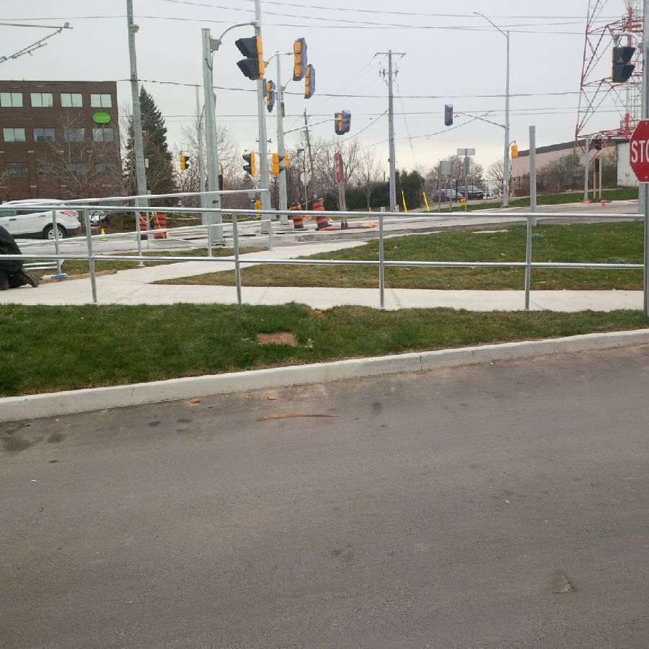
There were no accessible washrooms on the main level of Withdrawal Management. | In December 2016 renovations were made to two washrooms to make them accessible.
There was no accessible access for visitors dropping off resumes to the Human Resources Department | In November 2016 a door operator was installed on the main entrance to HR Dept. | 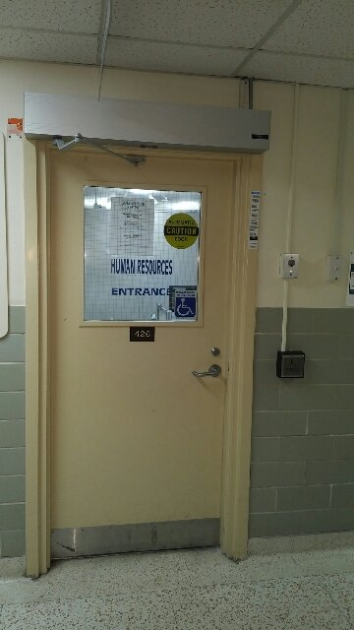
Washrooms near Physical Medicine clinic did not have door operators | New door operators on new accessible washrooms at Freeport | 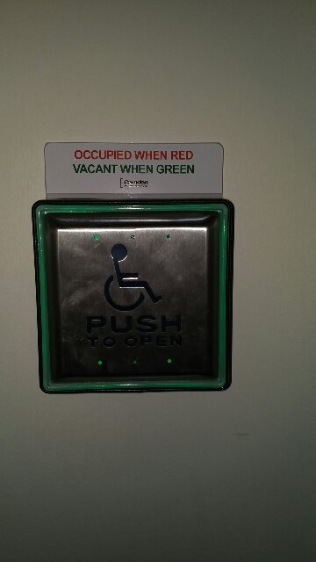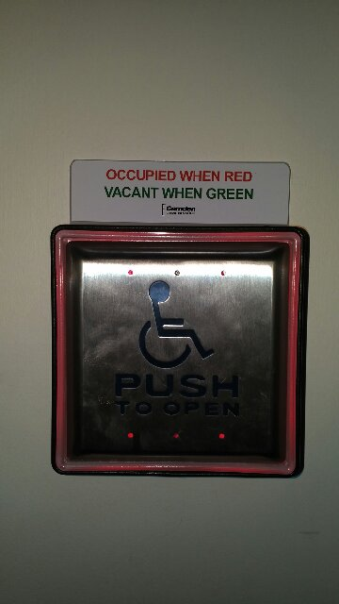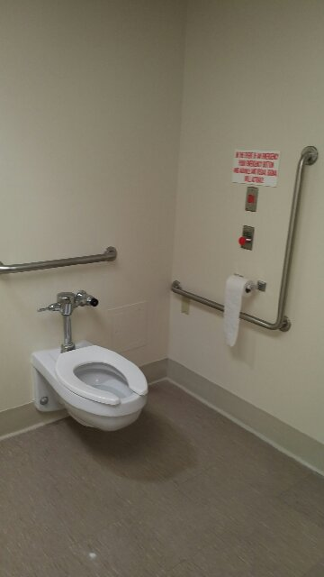
Poorly identified change in flooring elevations at the ramp on the 5th and 6th floor of the Kaufman building. | In October 2016 visual cues were installed. | 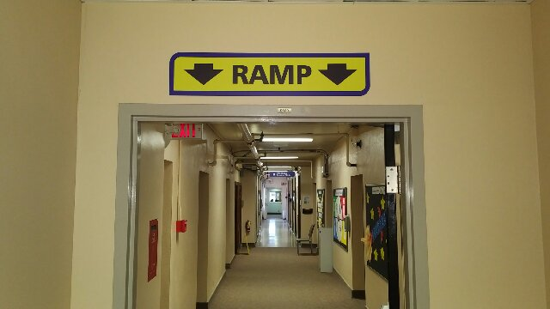
No barrier free access to the healing gardens between Kaufman and Cancer Center buildings | Door operators installed at both entrances | 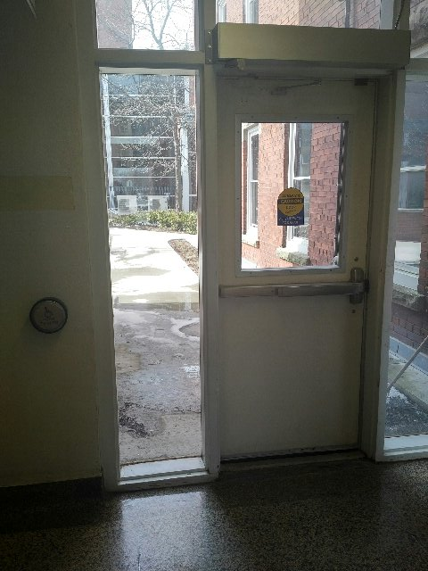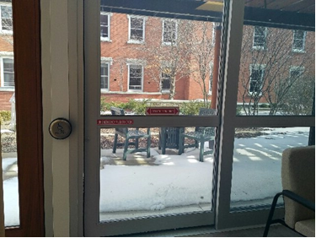
Pay & Display meters were not at accessible height | Select meters were lowered to an accessible height. | 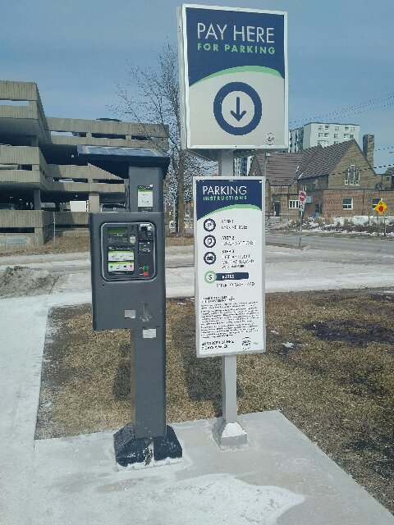
The waste and recycling station at the KW Site Cafeteria was not an accessible height | A new station was custom built to meet accessibility height standards. | 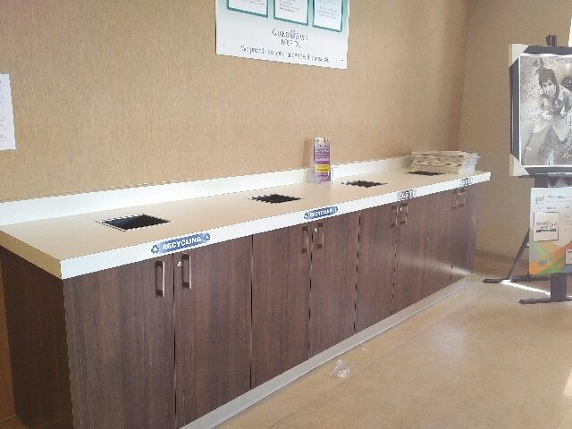
There was no handrail along the sidewalk leading up to Kaufman building and Green Street. | In April 2016, a new handrail was installed along sidewalk. | 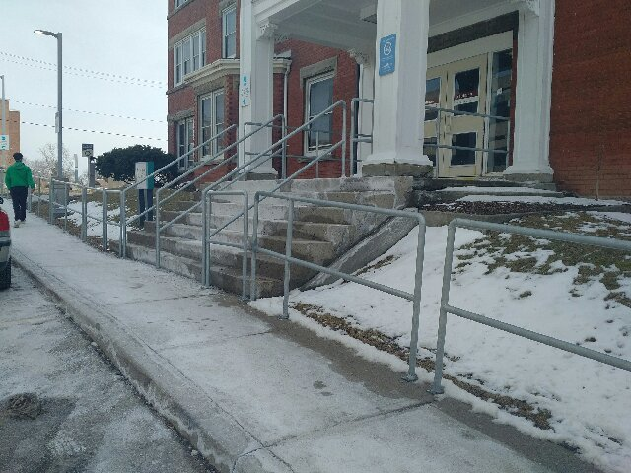
In addition to the above initiatives the following work has been undertaken in 2016 to achieve compliance with the upcoming Integrated Accessibility Standards Regulations.

AODA Standards / Regulation Reference O. Reg.191/11, s. 14 | II: Accessible Web Sites and Web Content  Compliance Deadline: January 1st 2021
14.1 Ensure internet websites and web content conform to WCAG 2.0 guidelines (Web Content Accessibility Guidelines) at the following levels:  - All websites and web content to Level AA by January 1, 2021 (other than live captions and audio descriptions) (14.4) | Website and web content conform to WCAG 2.0 Level A guidelines with some exceptions which we have workarounds for (i.e. photos).  Working with the successful vendor and internal stakeholders to develop the new website. Accessible pdfs are front and centre in their work. GRH is moving towards converting pdfs to accessible web content or having a tool to make pdfs accessible.  Completed January 2016 and ongoing.

AODA Standards / Regulation Reference O. Reg.191/11,  S. 80.16, 80.22, 80.33-80.37, 80.39-80.42 | IV: Design of Public Spaces (DRAFT)  Compliance Deadline: Estimated as January 1st, 2016
All sections of the Built Environment Standards (Design of Public Spaces) with relevance to GRH | The Accessibility Committee, which includes membership from Planning, Development and Facility Redesign and Engineering Services, has reviewed the new accessibility amendments to Ontario’s Building Code and the new accessibility standards for the built environment.  Completed December 2016 and ongoing.
Ss. 80.33 to 80.37
Accessible Parking
Ss. 80.16, 80.22, 80.28
Exterior Spaces
Ss. 80.39 to 80.41
Interior Spaces
Ss. 80.42
Maintenance

