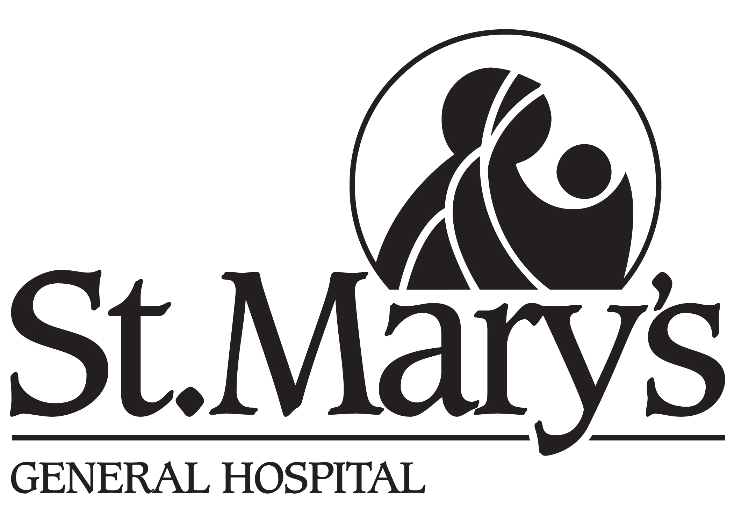

TRI-HOSPITAL RESEARCH ETHICS BOARD (THREB)

ANNUAL RENEWAL PROGRESS REPORT FORM

FOR ONGOING RESEARCH STUDIES

This form is available in MS WORD and can be downloaded at: www.grandriverhospital.on.ca

All submissions must be typed. (Handwritten submissions will not be accepted.)

Use this form if data are being collected or participants are still being followed and renewal of approval is being requested. If all data collection and participant follow-up has ended or study is cancelled, submit a Study Completion Report even if data analysis continues.

THREB Study #:

Full Research Study Title:

Name of Local Responsible Investigator and Contact Information:

Initial Approval Date:

Date Approval Renewal Required (Anniversary Date):

Site(s) involved:
[ ] GRH – KWHC
[ ] GRH – Freeport
[ ] GRH – GRRCC
[ ] SMGH
[ ] CMH
[ ] Other ______________________________

Please answer all questions.

Local Study Status: Check [ ✓ ] (one only)
Actively enrolling participants [ ]

Enrolment completed, but participants being followed [ ]

Chart review only [ ]

Other (Attach explanation [ ]

- Enrollment:
How many participants have been enrolled to date? _____

How many participants have left study for reasons other than completing it: _____
(i.e., died, withdrew due to AE or for personal reasons, etc. Give explanation.)

NOTE: For chart research, state # of charts under “enrolled” field.

- Please provide a brief summary of the study results to date,
including any difficulties encountered conducting the study,
i.e. funding, study design, recruitment, data management,
interactions with the sponsor(s). [ ]Attached

- Has an interim data analysis been done? [ ] Yes [ ] No
If yes, attach a summary. [ ] Attached

- Have any articles been published or presentations given
using the results of the study? [ ] Yes [ ] No
If yes, please submit a copy of the abstract(s) or a list of references. [ ] Attached

- Have there been any changes to the study protocol or
consent form since the last approval? [ ] Yes [ ] No
If yes, have these changes been approved by THREB? [ ] Yes [ ] No
If no, attach completed Amendment Form. [ ] Attached

- What is the version date of the consent form currently being used? __________________ [ ] N/A

- Have there been any local serious adverse events? [ ] Yes [ ] No
If yes, has the THREB been notified? [ ] Yes [ ] No
If no, submit Local SAE Report now. [ ] Attached

- For clinical trials, the most recent DSMB or Sponsor-generated
report is required. Is it attached? [ ] Yes [ ] No [ ] N/A

- Has there been any new literature which would change
your assessment of risk/benefit for participants? [ ] Yes [ ] No
If yes, and your assessment of risk has increased, have
your participants been informed? [ ] Yes [ ] No
If no, indicate when and how this will take place. [ ] Attached

- Have there been any changes in investigators since the
last approval? [ ] Yes [ ] No
If yes, has the THREB been notified? [ ] Yes [ ] No
If no, submit changes now on an Amendment Form. [ ] Attached

- Is there new evidence from other studies that impact
your study? [ ] Yes [ ] No
If yes, provide. [ ] Attached

12. Has any further conflict of interest arisen in the study? [ ] Yes [ ] No
If yes, provide explanation. [ ] Attached

It is the responsibility of the researcher to notify the Tri-Hospital Research Ethics Board of any procedural change in research involving human participants.

_________________________________________ _______________________
Signature of Local Responsible Investigator Date

Please sign and submit this completed form (original + 4 copies) to:

Shelley Croth, Administrative Coordinator
Tri-Hospital Research Ethics Board
Grand River Hospital, Kaufman Building, Rm K415
835 King Street West
Kitchener, ON. N2G 1G3
Phone #1-519-749-4300, extension 5367
FAX #1-519-749-4282
Email: shelley.croth@grhosp.on.ca

