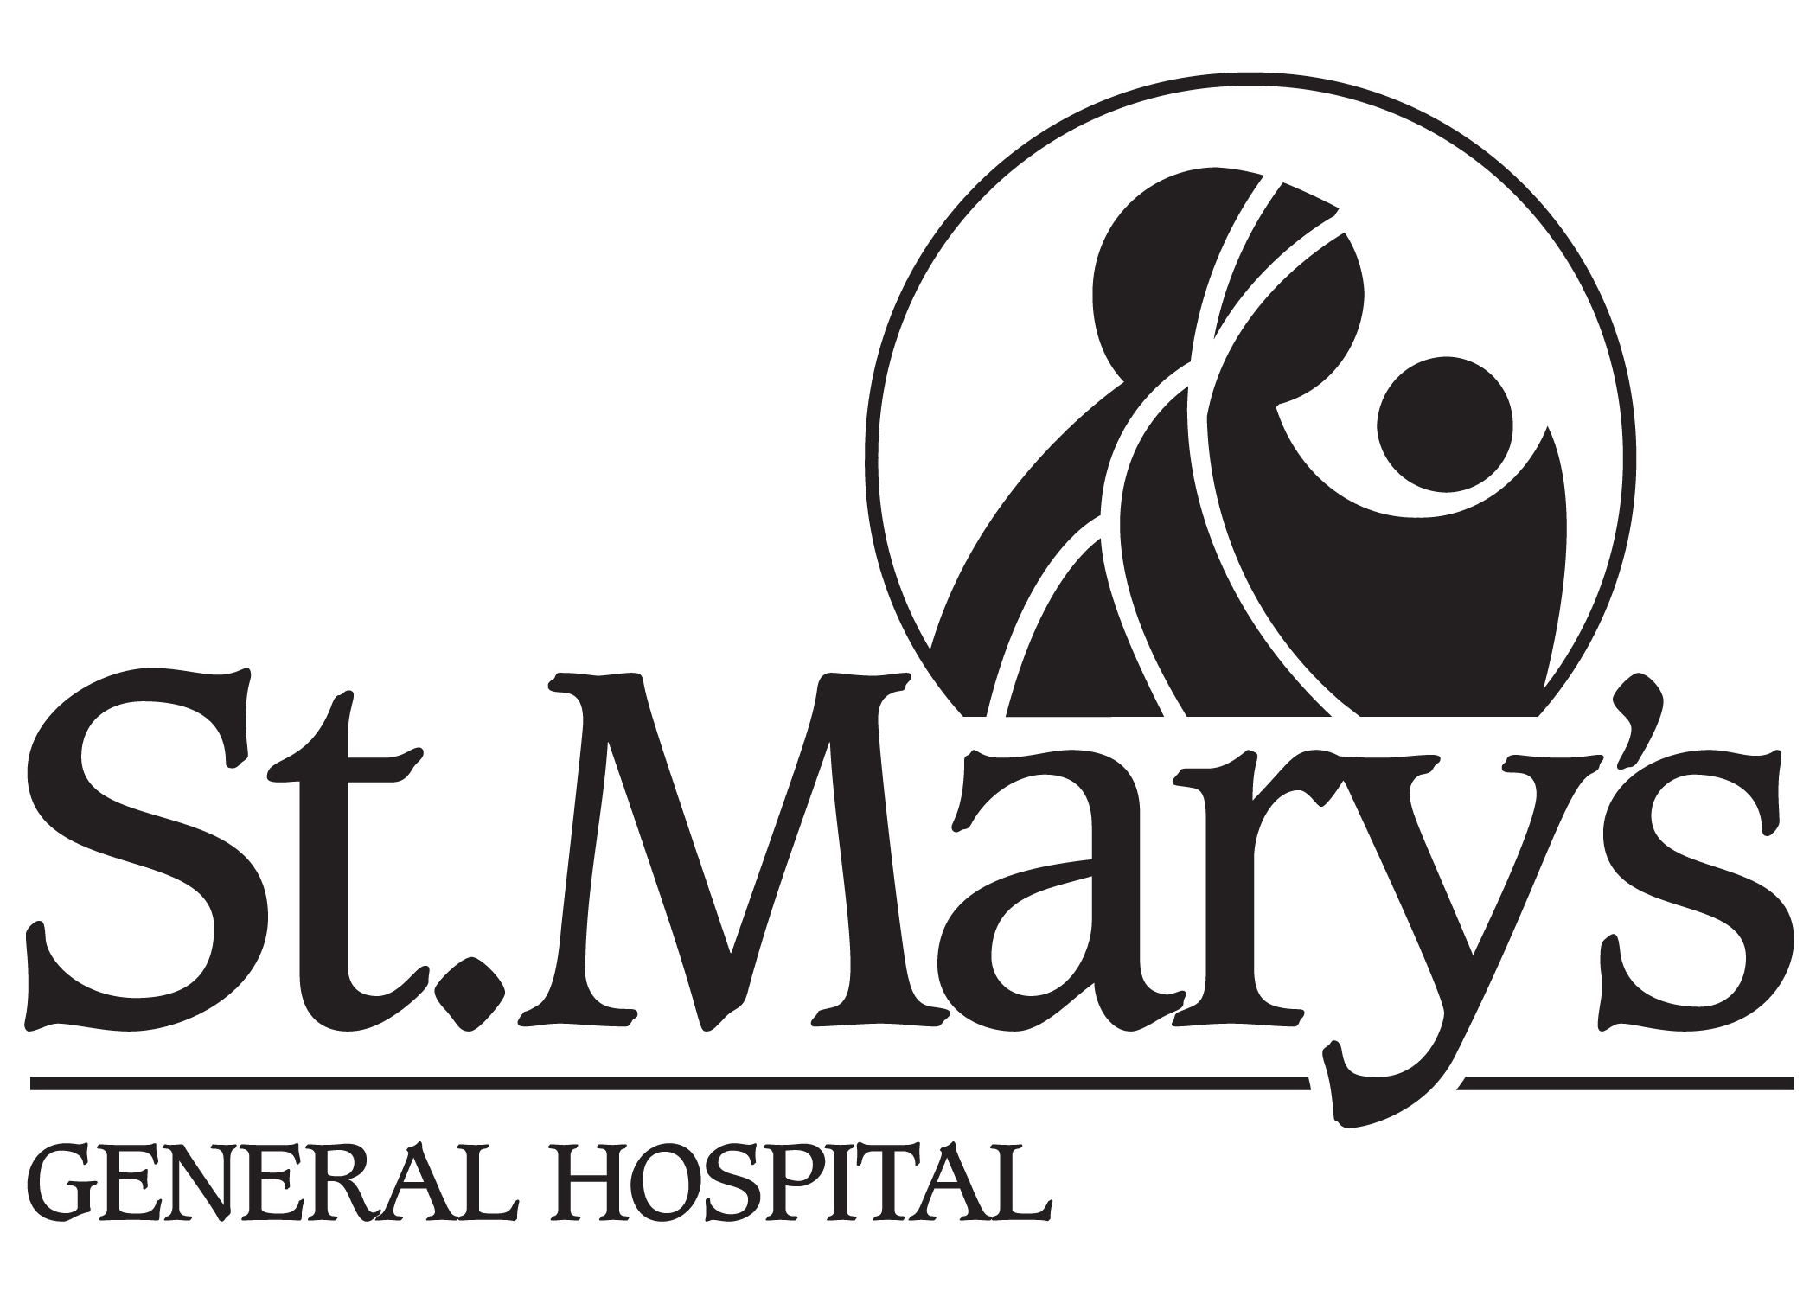

TRI-HOSPITAL RESEARCH ETHICS BOARD (THREB)

AMENDMENT TO RESEARCH

REQUEST FORM FOR APPROVAL OF AMENDMENT

TO PROTOCOL, CONSENT FORM or ADMINISTRATIVE or PERSONNEL CHANGES
All submissions must be typed, excepting check marks and signature. (Handwritten submissions will not be accepted.)

1. THREB #

2. INVESTIGATOR

3. TITLE of Protocol

4. The following over-all evaluation of the amendment is given by the locally responsible investigator:

[ ] Minor (no increase of risk or burden on research subject and no implication for hospital resources; includes changes that are only administrative)

[ ] Moderate (some substantive changes in protocol that require explanation to patient/subject)

[ ] Major (may alter originally proposed study outcomes, including statistical power, risks or benefits)

5. Do changes involve increased risk, burden or discomfort for participants? ( ) Yes ( ) No

6. Does the consent form require modification due to these changes? ( ) Yes ( ) No
If "Yes", is a modified form included? ( ) Yes ( ) No

7. Provide a brief summary or overview of the changes, either in the space below or in a
cover letter.

8. ATTACH A DETAILED DESCRIPTION OF CHANGES.
THESE SHOULD BE FORMATTED AS DESCRIBED ON THE FOLLOWING PAGE.

9. Was this a coordinated review with the University of Waterloo? ( ) Yes ( ) No
If yes, provide the UWaterloo ORE #: [ ]

Name of Local Responsible Investigator:
(Print or Type Name)

Signature of Local Responsible Investigator:

Date:

Amendments must be submitted in such a way that the THREB members can easily see:
1. the old wording;
2. the new wording;
3. the rationale or justification for each change.

For Consent Forms especially, the following should be the norm. Exceptions must be justified.
- The old wording is clearly identified and printable in black & white (for example, bolded strikethrough text).
- The new wording is clearly identified and printable in black & white (for example, italicized grey-shaded text).
- It is clear why each amendment has been made (the rationale is given).
- It is clear whether each amendment increases risk or discomfort for the participant in any way.

Please submit:
- One (1) hard copy of a typed completed Amendment Request Form with original signature of the Locally Responsible Investigator, and four (4) additional hard copies of the form.
- An electronic copy, if possible, of each of the documents below, sent to shelley.croth@grhosp.on.ca
- Five (5) hard copies (collated) with each of the following:
  - A cover letter from the Investigator or sponsor summarizing the changes and rationale. Moreover, for changes in lengthy protocols, a summary with old wording, new wording, and rationale or detailed explanation for each change can be substituted for a full protocol with tracked changes and rationale as indicated below.
  - For changes to existing protocols:
    - One (1) clean hard copy of the amended protocol.
AND either
    - Four (4) hard copies of the amended protocol with tracked changes and rationale for each change,
Or
    - Four (4) hard copies of the summary with old wording, new wording and rationale for each change.
  - For changes to existing information sheet/consent form, advertisement, study instrument, questionnaire, etc :
    - One (1) clean hard copy of the amended document and
    - Four (4) copies of the amended document with changes “tracked” as indicated above and with a detailed explanation/rationale for the changes.
  - For new documents:
    - Four (4) copies of any new document (e.g. protocol, information sheet/consent form, drug or device brochure, advertisement, study instrument, questionnaire, etc.) including a rationale for adding the new document.
- One (1) hard copy of and new or amended investigator’s brochure for drugs or devices (electronic version not needed).

Mail completed materials to: Shelley Croth, Administrative Coordinator
Tri-Hospital Research Ethics Board
Grand River Hospital, Building-Forty Green, Rm K415
835 King Street West
Kitchener, ON. N2G 1G3
Email: shelley.croth@grhosp.on.ca

For Office Use Only THREB #____________

1. Amended protocol with changes and rationale indicated □ Yes □ No
2. Required number of copies □ Yes □ No
3. Changes tracked on revised consent form and other documents □ Yes □ No
4. Amendment Request Form signed by Local Responsible Investigator □ Yes □ No
5. Industry sponsored trial review fee received □ N/A □ Yes □ No

