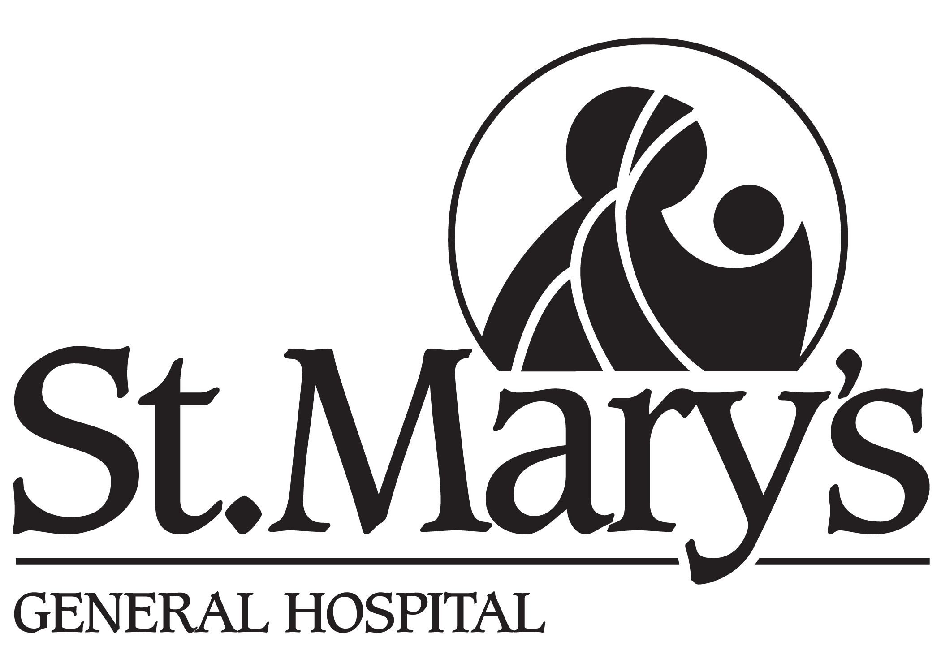

TRI-HOSPITAL RESEARCH ETHICS BOARD (THREB)

STUDY COMPLETION FORM FOR RESEARCH STUDIES

This form is available in MS WORD and can be downloaded at: www.grandriverhospital.on.ca
Complete the form in NO smaller than 10 point font; handwritten submissions are NOT acceptable

Use this form ONLY if all data has been collected and all contact with participants has concluded. The study may not be closed out until both are completed. However data analysis may continue after closure.

THREB # ________

Research Study Title:

Local Responsible Investigator:

Co-investigators:

Date study was initiated:

Date study was completed:

Site(s) involved:
[ ] GRH – KWHC
[ ] GRH – Freeport
[ ] GRH – GRRCC
[ ] SMGH
[ ] CMH
[ ] Other ______________________________

Please answer all questions. This form should be filled out to close a research study.

- Number of study participants:

What was the total number enrolled since initiation of the study? ______

How many participants were withdrawn or did not complete study: ______
(i.e., died, withdrew due to AE or for personal reasons, lost to follow-up, etc.)
Attach explanation.

How many Local Serious Adverse Events were there? ______

If any, were these reported to the THREB? [ ] Yes [ ] No

If not, submit Adverse Events Report to the THREB now. [ ] Attached

NOTE: For chart research, state # of charts under “enrolled” field.

- Have all study-related data analyses been completed? [ ] Yes [ ] No

- Have any articles been published or presentations given or pending
using the results of this study? [ ] Yes [ ] No
If yes, submit a copy of the abstract(s) or a list of references. [ ] Attached

- What arrangements have been made to store data in a secure/confidential manner?
Describe where and how long will data will be conserved?

- Please attach a brief description of study findings. [ ] Attached

I certify that as of the date below, participants are no longer being studied or followed and that this study should be officially terminated by the THREB.

_____________________________________ _______________________
Signature of Investigator Date

Please sign and submit this completed form (original + 4 copies) to:

Shelley Croth, Administrative Coordinator
Tri-Hospital Research Ethics Board
Building-Forty Green, Rm K415
Grand River Hospital
835 King Street West
Kitchener, ON. N2G 1G3
Phone #1-519-749-4300, extension 5367
FAX #1-519-749-4282
Email: shelley.croth@grhosp.on.ca

